SPECIFICATION
Hippo-M MAX Connector
10mm PCB 2 Pins for COB/SMD
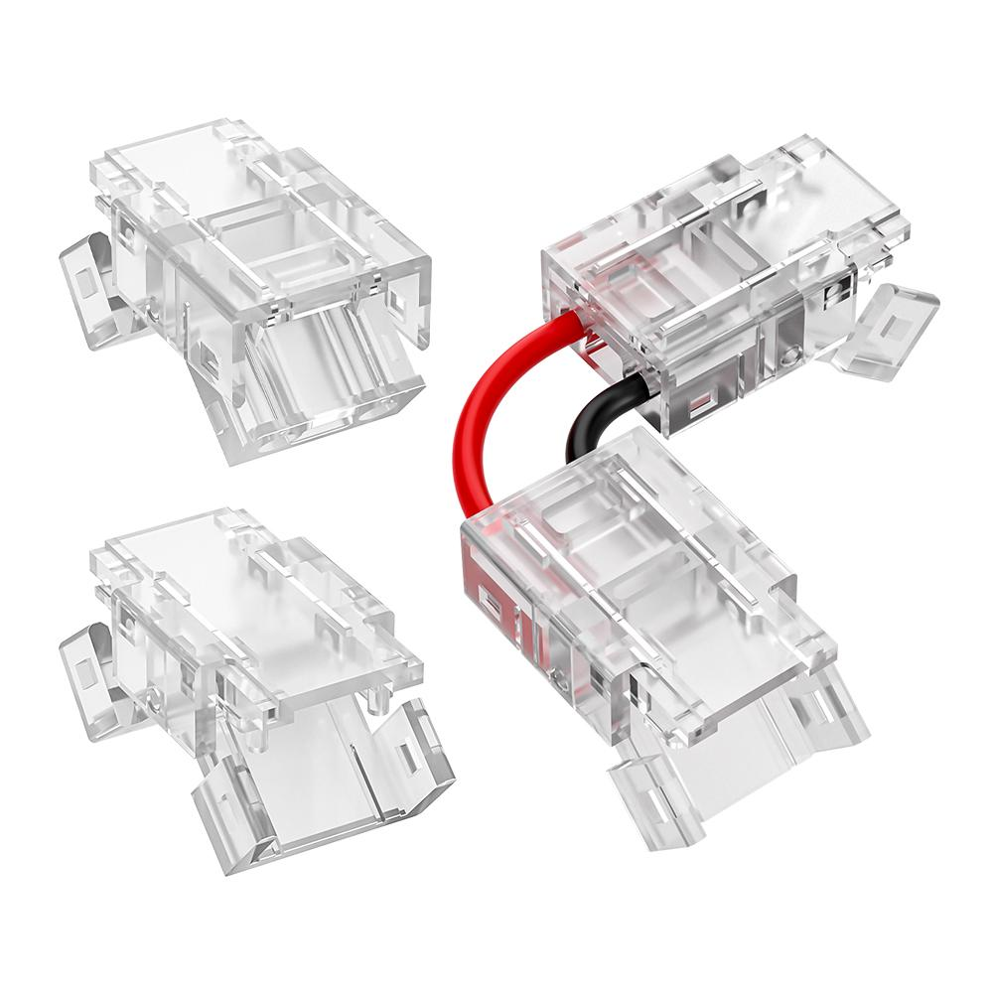

Basic Info
Product Series | Hippo-M MAX
Item NO. | MX/2045-X10C-2P | MX/2045-B10C-2P | MX10BXB-L2C
Connection Type | Strip to Wire | Strip to Strip Joint | Corner Strip to Strip Bridge
With Wire or NOT | No wire | No wire | with wire (20AWG/0.52mm²)

Physical Data
Item NO. | MX/2045-X10C-2P | MX/2045-B10C-2P | MX10BXB-L2C
Shape | I shape, straight connection | I shape, straight connection | L shape, Corner connection
Size | 19*12.6*6.2 | 19.8*12.6*6.2 | 36.6*36.6*6.2
Pin Quantity | 2 | 2 | 2
Notch Width | 5.0mm | 5.0mm | 5.0mm
Size detail, pls refer to below Dimensional Diagram

Material Data
Housing Color | Transparent
Material | Polycarbonate(PC), Phosphor bronze
Surface Treatment | Nickel plating
Housing Deform Temperature | 80℃

Electrical Data
Item NO. | MX/2045-X10C-2P | MX/2045-B10C-2P | MX10BXB-L2C
Voltage | DC3~48V | DC3~48V | DC3~48V

Current & Temperature
Item NO. | Max Current | PCB Copper Thickness Required | Temperature Raise (ΔT) | Max LED Strip Temperature T(strip)
MX/2045-X10C-2P | 4A | 2 OZ | 10℃ | 65℃
MX/2045-X10C-2P | 5.0A | 3 OZ | 10℃ | 65℃
MX/2045-B10C-2P | 3.0A | 2 OZ | 10℃ | 65℃
MX/2045-B10C-2P | 4.0A | 3 OZ | 10℃ | 65℃
MX10BXB-L2C | 4A | 2 OZ | 10℃ | 65℃
MX10BXB-L2C | 5.0A | 3 OZ | 10℃ | 65℃
Note: Test with @TA=30℃ Wire Gauge=20AWG
Remark
- ΔT = Inner Temperature Raise for reference;
- T(strip) = temperature of working led strip
- In actual application, make sure T(strip) doesn't exceed the highest temperature listed above
( For example T(strip)<=60℃) otherwise lower the pcb current or apply extra cooling for long term working

Workable LED Strip
Type | COB/SMD
Size（WxH） | 10x3.9 mm
Light Color | MONO
IP Rating | IP20 / IP65 silicon
PCB Thickness | 0.25 ~0.35 mm
LED Density/ Meter | No Limited to COB，if SMD , it depends on SMD size

Workable Wire Data
AItem NO. | MX/2045-X10C-2P
Wire Gauge | Best fit 18AWG/0.78mm² (PVC) & 18AWG/0.78mm² (Teflon) ; 20AWG/0.52mm² (PVC)
Outer Diameter | MONO OD＜2.1mm

Working Environment
Environment TEMP. | -10 ~ 45℃
Environment | Indoor

Dimensional Diagram
Item NO.: | MX/2045-X10C-2P
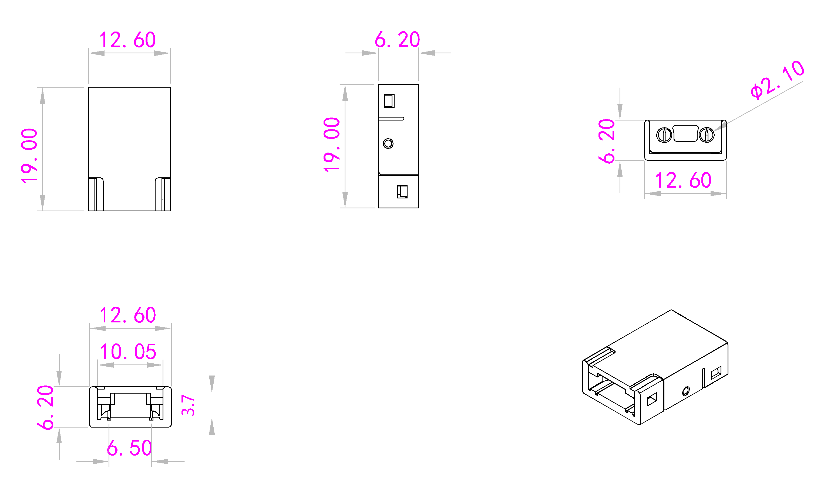
Item NO.: | MX/2045-B10C-2P
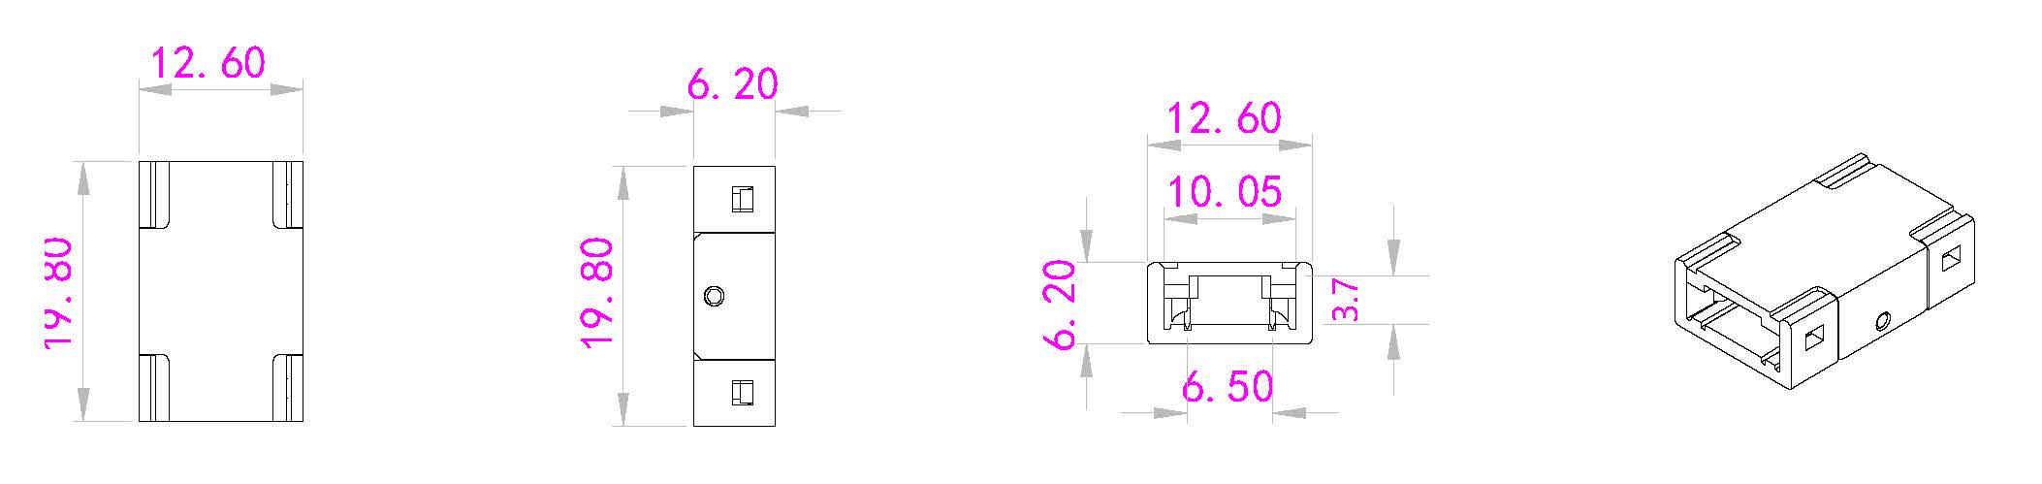

Item NO.: | MX10BXB-L2C
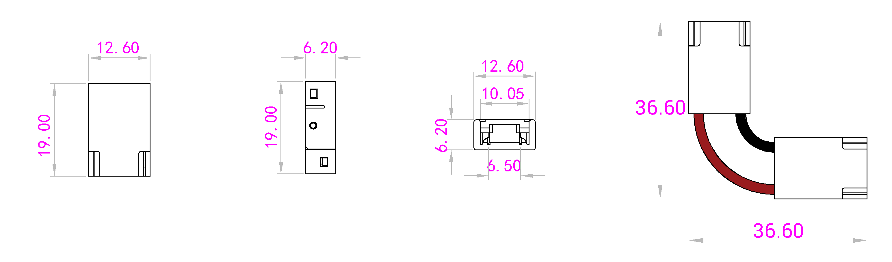
Tolerance（mm）
Size Range | Tolerance
≤3 | ±0.10
＞3≤10 | ±0.15
＞10≤20 | ±0.20
＞20 | ±0.25
If the diagram has marked the tolerance data, use it as a standard; If not , take the tolerance table as standard.

